**Test your skills: The Box Model**

## The Box Model One

With the two boxes below, one is using the standard box model, the other the alternate box model. Change the width of the second box by adding rules to the .alternate class, so that it matches the visual width of the first box. Your final result will look like the image below.

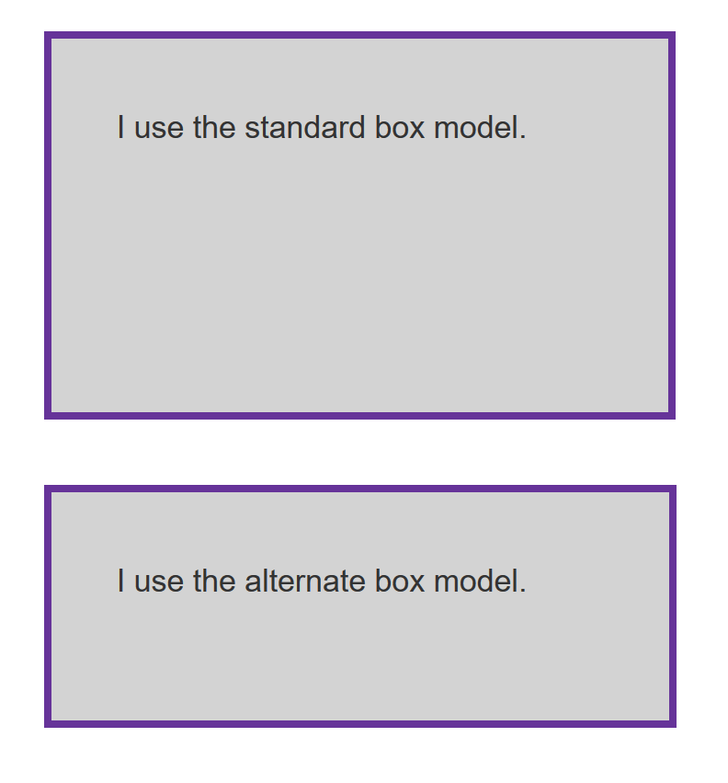

Try updating the code below to recreate the finished example:

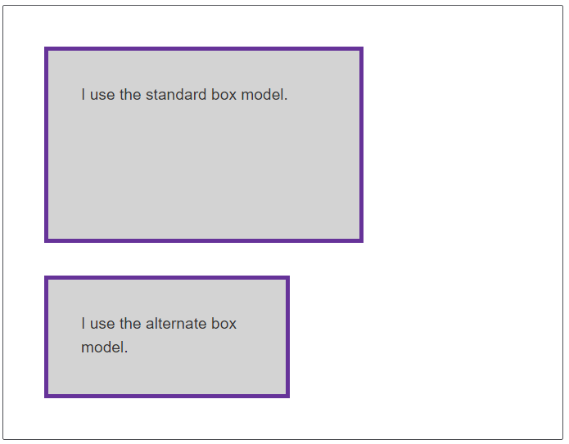

.box {

border: 5px solid rebeccapurple;

background-color: lightgray;

padding: 40px;

margin: 40px;

width: 300px;

height: 150px;

}

.alternate {

box-sizing: border-box;

}

<div class="box">I use the standard box model.</div>

<div class="box alternate">I use the alternate box model.</div>

## [The Box Model Two](https://developer.mozilla.org/en-US/docs/Learn/CSS/Building_blocks/Box_Model_Tasks#the_box_model_two)

In this task, add to the box:

* A 5px, black, dotted border.
* A top margin of 20px.
* A right margin of 1em.
* A bottom margin of 40px.
* A left margin of 2em.
* Padding on all sides of 1em.



Try updating the code below to recreate the example as displayed in the image:



.box {

}

<div class="box">I use the standard box model.</div>

## [The Box Model Three](https://developer.mozilla.org/en-US/docs/Learn/CSS/Building_blocks/Box_Model_Tasks#the_box_model_three)

In this example the inline element has a margin, padding and border; however, the lines above and below are overlapping it. What can you add to your CSS to cause the size of the margin, padding, and border to be respected by the other lines, while still keeping the element inline?

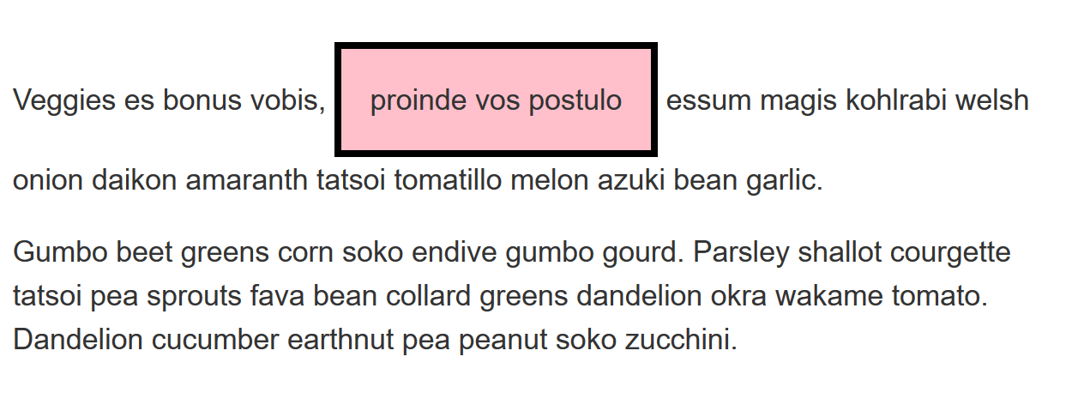

Try updating the code below to recreate the finished example:

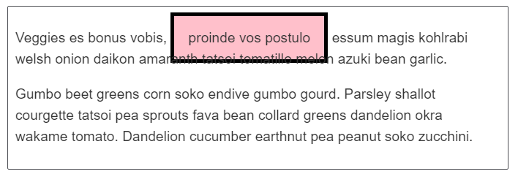

.box span {

background-color: pink;

border: 5px solid black;

padding: 1em;

}

<div class="box">

<p>Veggies es bonus vobis, <span>proinde vos postulo</span> essum magis kohlrabi welsh onion daikon amaranth tatsoi tomatillo melon azuki bean garlic.</p>

<p>Gumbo beet greens corn soko endive gumbo gourd. Parsley shallot courgette tatsoi pea sprouts fava bean collard greens dandelion okra wakame tomato. Dandelion cucumber earthnut pea peanut soko zucchini.</p>

</div>